

Biosafety Signs for Laboratory Use

Important Notice: The appropriate completed biohazard sign must be posted at the room entrance whenever biohazards are present in the room.

NOTE: THESE SIGNS ARE WORD FORMS. TO SCROLL FROM EACH FIELD, HIT THE TAB KEY. PLEASE NOTE THAT THE SIGNS MUST BE PRINTED ON A COLOR PRINTER.

Please contact Virginia Sykes in the BioSafety Office at (804)-828-2950 if you have questions about these signs.

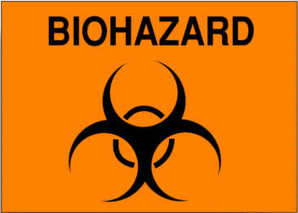CAUTION

AUTHORIZED PERSONNEL ONLY

BIOSAFETY LEVEL:

ETIOLOGIC AGENT:

PRINCIPAL INVESTIGATOR:

TELEPHONE NUMBER OF LAB:

REQUIRED IMMUNIZATIONS:

PPE REQUIRED:

SPECIAL HAZARDS:

ATTENTION: IMMUNOCOMPROMISED PERSONNEL ARE AT INCREASED RISK FROM EXPOSURE TO ALL HUMAN PATHOGENS. PLEASE ENSURE THAT IT IS SAFE FOR YOU TO ENTER THIS ROOM.

OEHS RECOMMENDS THAT ALL IMMUNOCOMPROMISED PERSONS DO NOT HANDLE BIOHAZARDOUS AGENTS.

PROCEDURES FOR ENTERING/EXITING THE LAB: Wear PPE listed above upon entering lab. All disposable PPE should be autoclaved or disposed of in a red incineration bag. Non-disposable PPE should stay in the lab.

OHS EMERGENCY NUMBERS:
For emergency response during work hours: 828-9834.

